NAME : SAYANTAN CHAUDHURI
SUPERSET ID : 6365368

- What is ORM?

Answer :

ORM (Object-Relational Mapping) is a technique that allows you to interact with a database using C# objects instead of SQL.
Example Mapping:
A Product class in C# becomes a Products table in SQL.

public class Product
{
public int Id { get; set; }
public string Name { get; set; }
}

This means :
Class = Table , Property = Column , Object = Row

- EF Core vs EF Framework.

Answer :

Features | EF Core | EF Framework
Platform | Cross-platform (.NET Core) | Windows only (.NET Framework)
Speed | Faster with compiled queries | Slower
Modern Features | LINQ, Async, JSON columns, Bulk ops | No modern features
Future Proof | Ongoing updates | Legacy

- EF Core 8.0 Features:

Answer :
- JSON column mapping: Store structured JSON data in SQL columns.
- Compiled models: Greatly improves startup performance.
- Interceptors: For auditing/logging DB operations.
- Better bulk operations: Efficient AddRange, UpdateRange, etc.

- Create a .NET Console App:

Solution :

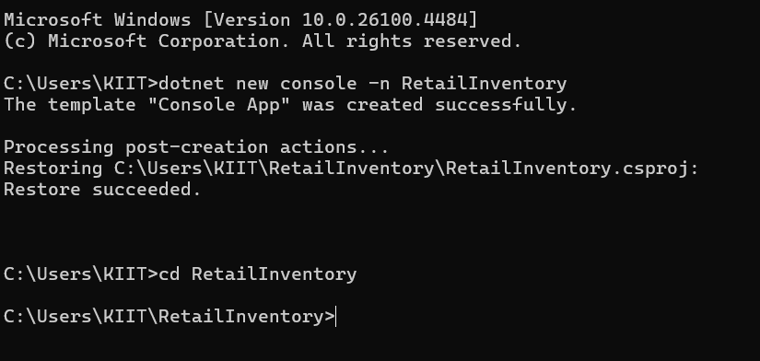

- Install EF Core Packages:

Solution :

